Book Collection Management System

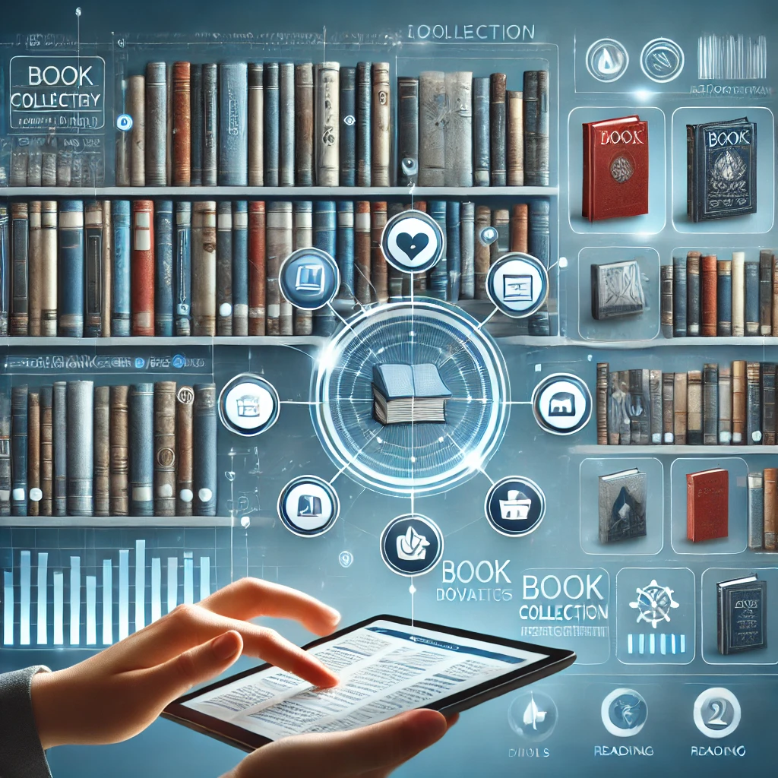

Contents

3

Team Members & Their Contributions: 4

Introduction, System Overview & System Idea Summary 5

What Information Will the System Offer the User? 6

What Data Will Be Stored by the System? 6

Attributes 7

Where will we get this data? 9

Use Cases 10

Target Users 10

Comparable Systems & Differentiation 12

HOW ITS UNIQUE? AND ITS ASPECT? 14

Problem Domain Sketch 15

References 16

# Team Members & Their Contributions:

**Bhanu:**

- Introduction and System Overview

- System Idea Summary

- Problem Domain Sketch

- Attributes

- References

- Photos

**Jaspreet:**

- What Information Will the System Offer the User?

- What Data Will Be Stored by the System?

**Sahib:**

- Where will we get this data?

- Use Cases

**Mandeep:**

- Target Users

- Comparable Systems & Differentiation

# Introduction, System Overview & System Idea Summary

Our project has been named the Book Collection Management System (BCMS), and its main aim will be to help bibliophiles organize their libraries efficiently. The majority of enthusiastic readers accumulate big libraries, and the issue of how to sort and organize the numerous books can be acute. To fulfil this need, the BCMS was built having several key features;  
  
These include:  
  
- Adding Books: Users can book a new book to their library by keying in the details of the book or by using an ISBN barcode scanner on the book. This opens up the easy compilation of an entire personal library.  
  
- Reading Progress Tracking: The system shows books that are being read at that given time and the extent to which the user has read; features include the number of pages of the book the user has read.  
  
- Loaning and Borrowing: Borrower and lender aspect – it allows users to track books that one has loaned to friends or those that one borrowed from friends with dates and periods of loan.  
  
- Personalized Book Recommendations: According to the books that a user have read, as well as when entering the preferences, BCMS offers the user to read those books that can potentially interest the user.  
  
- Book Collection Insights: Due to the presented system, a user is aware of the books at his disposal and his or her reading preferences, which can help decide on what to read in the future and look through the previous literature.  
  
BCMS was envisaged to be the perfect solution to the management of personal book collections with as little fuss as can be imagined. Anything that gives its user satisfaction in reading and a desire to preserve the order amongst books is highly valuable with this system in place.

# 

# What Information Will the System Offer the User?

The BCMS will give users this information: According to the developed BCMS, users will obtain the following information:

1. Book Details: The readers shall be able to see such details for each book in the collection as title, author, publisher, picture, price, rating, reediness etc. It entails the title of the book, the author, type of the books, year of publication, ISBN number, description of the book and the image of the cover page. Through this feature, the users can easily go to the relevant information concerning the books in a short time.

2. Reading Progress: The system will also show how each book is being taken at the given time like not started, in progress and done. It also let the users indicate the progress of reading the book through a bar at the bottom of the page. This feature allows the users, to monitor and moderate their reading activity.

3. Loan Management: Users of BCMS will have books which they have lent to friends or those which they borrowed from friends. It will also include such particular features as dates of the loan and dates when the material is due. Of particular important is the fact that the app helps the users in organizing their borrowed books and even when they are supposed to return them.

4. Recommendations: Recommendations of new books With the list of the books the user has read, as well as his/her interests the system will suggest the books to read. One of the most notable aspects of this application is the book recommender system that would suggest to the user the kind of book he/she would like in the light of the books that the user has read.

5. Collection Statistics: Thus, users can see the overall number of books in the library, belonging to what genres and, therefore, their preferences in reading. It also helps the users to make sense of their library, and to find out how they read and therefore which pattern fits them best.

# 

# What Data Will Be Stored by the System?

The BCMS will store several types of data to work well: There will be several kinds of data that should be placed in the BCMS in order that the BCMS will function properly:

1. User Data: Such data are for instance the user’s name, the email which the user create and form a password to log into the application. This

The data is needed for creating the account and for Account Management and for security of the data.

2. Book Data: The system will include registers for each of them containing the name of the book, title, the author, category, date of issue, number, a short description, an illustration of the cover and the publishing house. This is beneficial to the users in the sense that they receive all the information concerning the books.

3. Reading Progress Data: This comprises of the current status of each book; whether it is new, current, or completed; and the percentage to which it is read. It can therefore be employed to keep track of, and facilitate the regulation of, the process of reading.

4. Loan Data: The records of the loans and/or borrowings and more so the records which bear names of the borrowers or lenders as well as the date/s on which the borrower/lender loaned/borrowed is also going to be stored in the system. This Assist in managing book loans proper.

5. Recommendation Data: After that, the system will begin to make a record of his reading history, as well as other tendencies, and thus, only those publications, which will be interesting for the reader, will be offered to him. From this data, people can be advised on the books they might like to read by their patterns of consumption.

6. Collection Statistics: This information will be collected to make use of it in making beautiful statistics and reports concerning of the books a certain user has read and those he or she is reading at the time being. This is important especially when attempting to have some notion of the assembled collection and the emerging trends which are visible.

# 

# Attributes

**1. User Data**

**•** UserID (Integer)

• UserName (String)

• Email (String)

• Password (String)

**2. Book Data**

**•** BookID (Integer)

• Title (String)

• Author (String)

• Category (String)

• DateOfIssue (Date)

• ISBN (String)

• Description (String)

• CoverImage (Binary)

• Publisher (String)

**3. Reading Progress Data**

**•** ReadingID (Integer)

• BookID (Integer)

• UserID (Integer)

• Status (Enum: They include New, In Progress and Completed.

• Progress (Float)

**4. Loan Data**

**•** LoanID (Integer)

• BookID (Integer)

• BorrowerID (Integer)

• LoanDate (Date)

• DueDate (Date)

• ReturnDate (Date)

**5. Recommendation Data (Generated Dynamically):**

**•** Derived Attributes:

• UserID (Integer)

• BookID (Integer)

• Genres (String, Array)

• Ratings (Float)

• Generated By: To suggest books, readng history, genre and ratings would be analyzed.

**6. Collection Statistics (Generated Dynamically):**

**•** Derived Attributes:

• TotalBooksRead (Integer)

• CurrentlyReading (Integer)

• ReadingTrends (String, Array)

• Generated By: Accomplishing totals and trends from the existent reading progress as well as user data.

# Where will we get this data?

The BCMS will get data from various things:

Firstly, it's USER INPUT as users can type details about their books and reading progress. Nowadays people are very healthy in using ONLINE DATABASES they work with public APIs (Application Programming Interfaces) like Google Books API, and Open Library API to fetch their book Data. We can also generate system data based on user actions related to reading progress, loan management, feedback, and collection statistics. However for the testing purposes we are going to use dummy data

# Use Cases

1. Add Book: It is easy to add books; one can enter a book detail or enter the ISBN(International Standard Book Number).

2. Edit Book Details: Readers can modify details related to books available with them.

3. Delete Book: It can show the books that the users have read The loaner users can unstuck books.

4. Track Reading Progress: The reading status and the current progress or statistics of the books being read can be modified by the users.

5. Loan Management: Employees and customers can document information of books that have been issued out and those that have been taken.

6. View Book Collection: Its features include the ability to browse and search at the list of all books a user has.

7. Receive Recommendations: Candidates can receive individualised book suggestions.

8. Generate Collection Statistics: Other uses are able to view the information related to the books and reading behavior.

# Target Users

Who uses a book management system? Well, there are a few different groups:

 1. Admins: These are the people in charge of the whole system. They add new books, update or delete old ones, manage user accounts, and set up who can do what.

 2. Librarians: These are the ones who run the library day-to-day. They check books in and out, help people find books, keep track of reservations, and make sure all the records are correct.

 3. Members (Library Patrons): These are the people who come to the library to borrow and return books. They can search for books, reserve them, see what they've borrowed before, and manage their account.

 4. IT Support/Developers: These are the tech experts who keep everything running smoothly. They fix any problems, update the system, make sure everything is secure, and might even add new features.

 Each of these groups has their own needs and things they need the system to do. The design of the system should make it easy for everyone to do their job and keep the library running smoothly.

 **(Library Science and Culture: Exploring the Art and Science of Libraries, 2023**)

# Comparable Systems & Differentiation

# Koha:

# What it is: In a library, a good example is Koha; it is one of the examples that most libraries in the entire world harness. This service is free of charge and is available to public, school and special libraries.

# What it does: This facilitates ordering, arrangement, storage of books and the dispersing of the same to people, members’ tracking, books buying, magazines management and reportage among others.

# What's good about it: many of which can be changed to your type of library, many people can assist if you are not sure, many of these are liberated for one to access.

# What's not so good: It is somewhat difficult to install as one wishes to have it and to operate it one has to have profound knowledge of the operating systems.

# Evergreen:

# What it is: Evergreen is therefore an integrated library system that is developed for use in large libraries and library networks.

# What it does: It was in used in shelving of books, issue of books, ordering of new books, Magazines, preparation of reports and above all self issuing of books.

# What's good about it: Especially in the cases of such large facilities as libraries there is always a segment of population willing to contribute with ideas for further improvements and this particular device is not expensive.

# What's not so good: Despite this, it may not be easy to install and manage and it may also take sometime for the user to familiarize with it.

# 

# Library World:

# What it is: Library World is an LSP that is both on the web and intended for small and medium circulation centres.

# What it does: They assist in such tasks as shelving of a book, borrowing of a book, control of the members, stock control and preparation of reports.

# What's good about it: It is also easy to access and one does not have to download this product and also it pocket friendly each month.

# What's not so good: Even in its current state, it cannot be easily moulded to your library’s needs and is perhaps not so ideal for huge libraries.

# (Koha, n.d.)

(**Lijon**, **2023**)



# HOW ITS UNIQUE? AND ITS ASPECT?

The Custom System is the superhero which your library needs! It has ones that made specifically for YOUR library and it’s needs. Other features that you can add them are; special reports, customized user types and linking it to other systems in your region.  
This one is versatile, wears a cool look and does not present a hard time when used by the generic end user. With an organized database, it can also adapt or develop with the library or as the library and your needs get larger.  
With the system integration, it can be linked to other tools that your library employs for learning, for instance, learning management systems or database solutions. And, in actuality, it could possibly save your money than how some of the other systems currently operate.  
Since you own and manage the data with the Custom System, you have the guarantee that your data won’t be compromised. It is possible to generate reports and analyzes for decision-making as well as develop individualized Recommendations for Books for the users.  
All in all, the Custom System is as if you are having an assistant solely for your library to perform lots of cool features to ease your tasks!

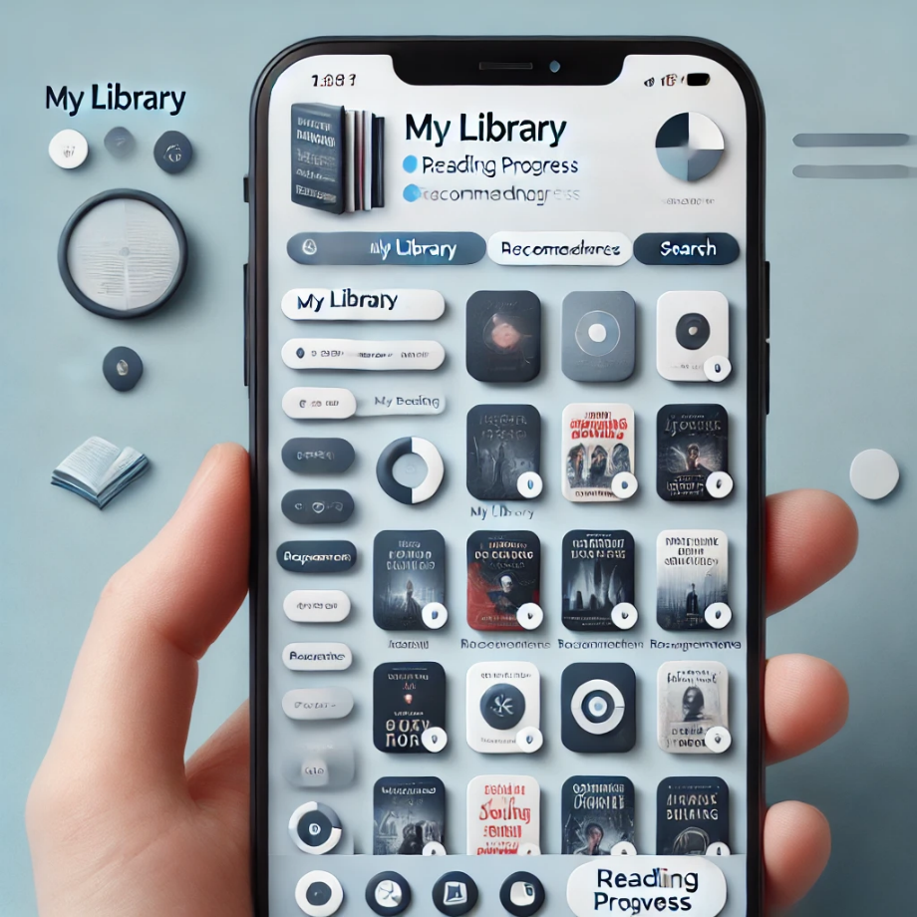

# Problem Domain Sketch

The BCMS connects users with book, loan management, and recommendation systems.

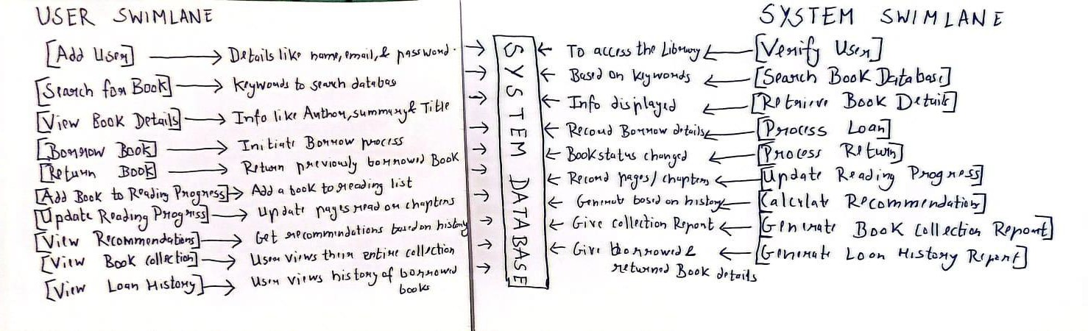

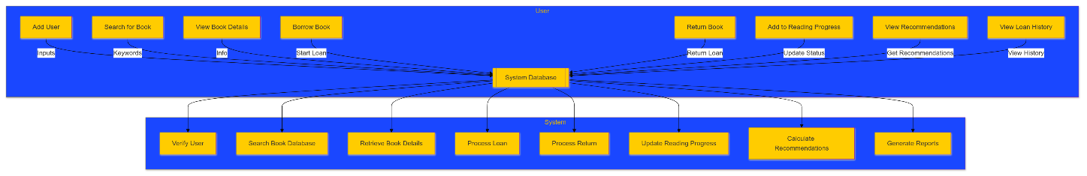

# References

*Koha*. (n.d.). Retrieved from Wikipedia: https://en.wikipedia.org/wiki/Koha_(software)

*Library Science and Culture: Exploring the Art and Science of Libraries*. (2023, December 14). Retrieved from https://www.libraryscienceandculture.com/2023/12/library-patrons-not-customers-upholding.html

Lijon. (2023, 08 30). *10 Best Library Management Software In 2023*. Retrieved from Medium: https://medium.com/@lijonseo/10-best-library-management-software-in-2023-fd6ef132f51e